Paid 4”x8” ($50) 8”x8” ($75) Date ______________________

**MILITARY MEMORIAL BRICKS Order Form for THE NEVER FORGET GARDEN**

Sponsored by the General James Jackson Chapter, NSDAR, and The Garden Center, Inc.

Please pay when you order. We will not be able to process your order until it is paid in full. Make check payable to The Garden Center, Inc.

Mail order form and check to

**The Garden Center, Inc.**

**P.O. 2423**

**Valdosta, GA 31604**

Name of Purchaser_____________________________________________________________________________

Address of Purchaser ___________________________________________________________________________

Email of Purchaser _____________________________________________________________________________

Best Phone Number of Purchaser _________________________________________________________________

For additional information, contact Patti Strickland (229) 560-1953 email: [*misspatti@windstream.net*](mailto:misspatti@windstream.net)

Referring to the Layout Page *on back*, please make your choices and fill in the relevant information.

1. Circle Brick Size and Layout (on back) 4x8 ($50) 8x8($75)

* Layout #1
* Layout #2
* Layout #3A Layout #3B Layout #3C Layout #3D

1. Choose free Emblem - Army Air Force Navy Marines Coast Guard WWII Army/Air Forces

|  |  |  |  |  |  |  |  |  |  |  |  |  |  |  |  |  |  |  |  |
| --- | --- | --- | --- | --- | --- | --- | --- | --- | --- | --- | --- | --- | --- | --- | --- | --- | --- | --- | --- |
|  |  |  |  |  |  |  |  |  |  |  |  |  |  |  |  |  |  |  |  |
|  |  |  |  |  |  |  |  |  |  |  |  |  |  |  |  |  |  |  |  |
|  |  |  |  |  |  |  |  |  |  |  |  |  |  |  |  |  |  |  |  |
|  |  |  |  |  |  |  |  |  |  |  |  |  |  |  |  |  |  |  |  |

1. Fill in (left to right) exactly, in upper-case letters, what you want on your brick. The lettering will correspond with the layout.

Line 1

Line 2

Line 3

Line 4

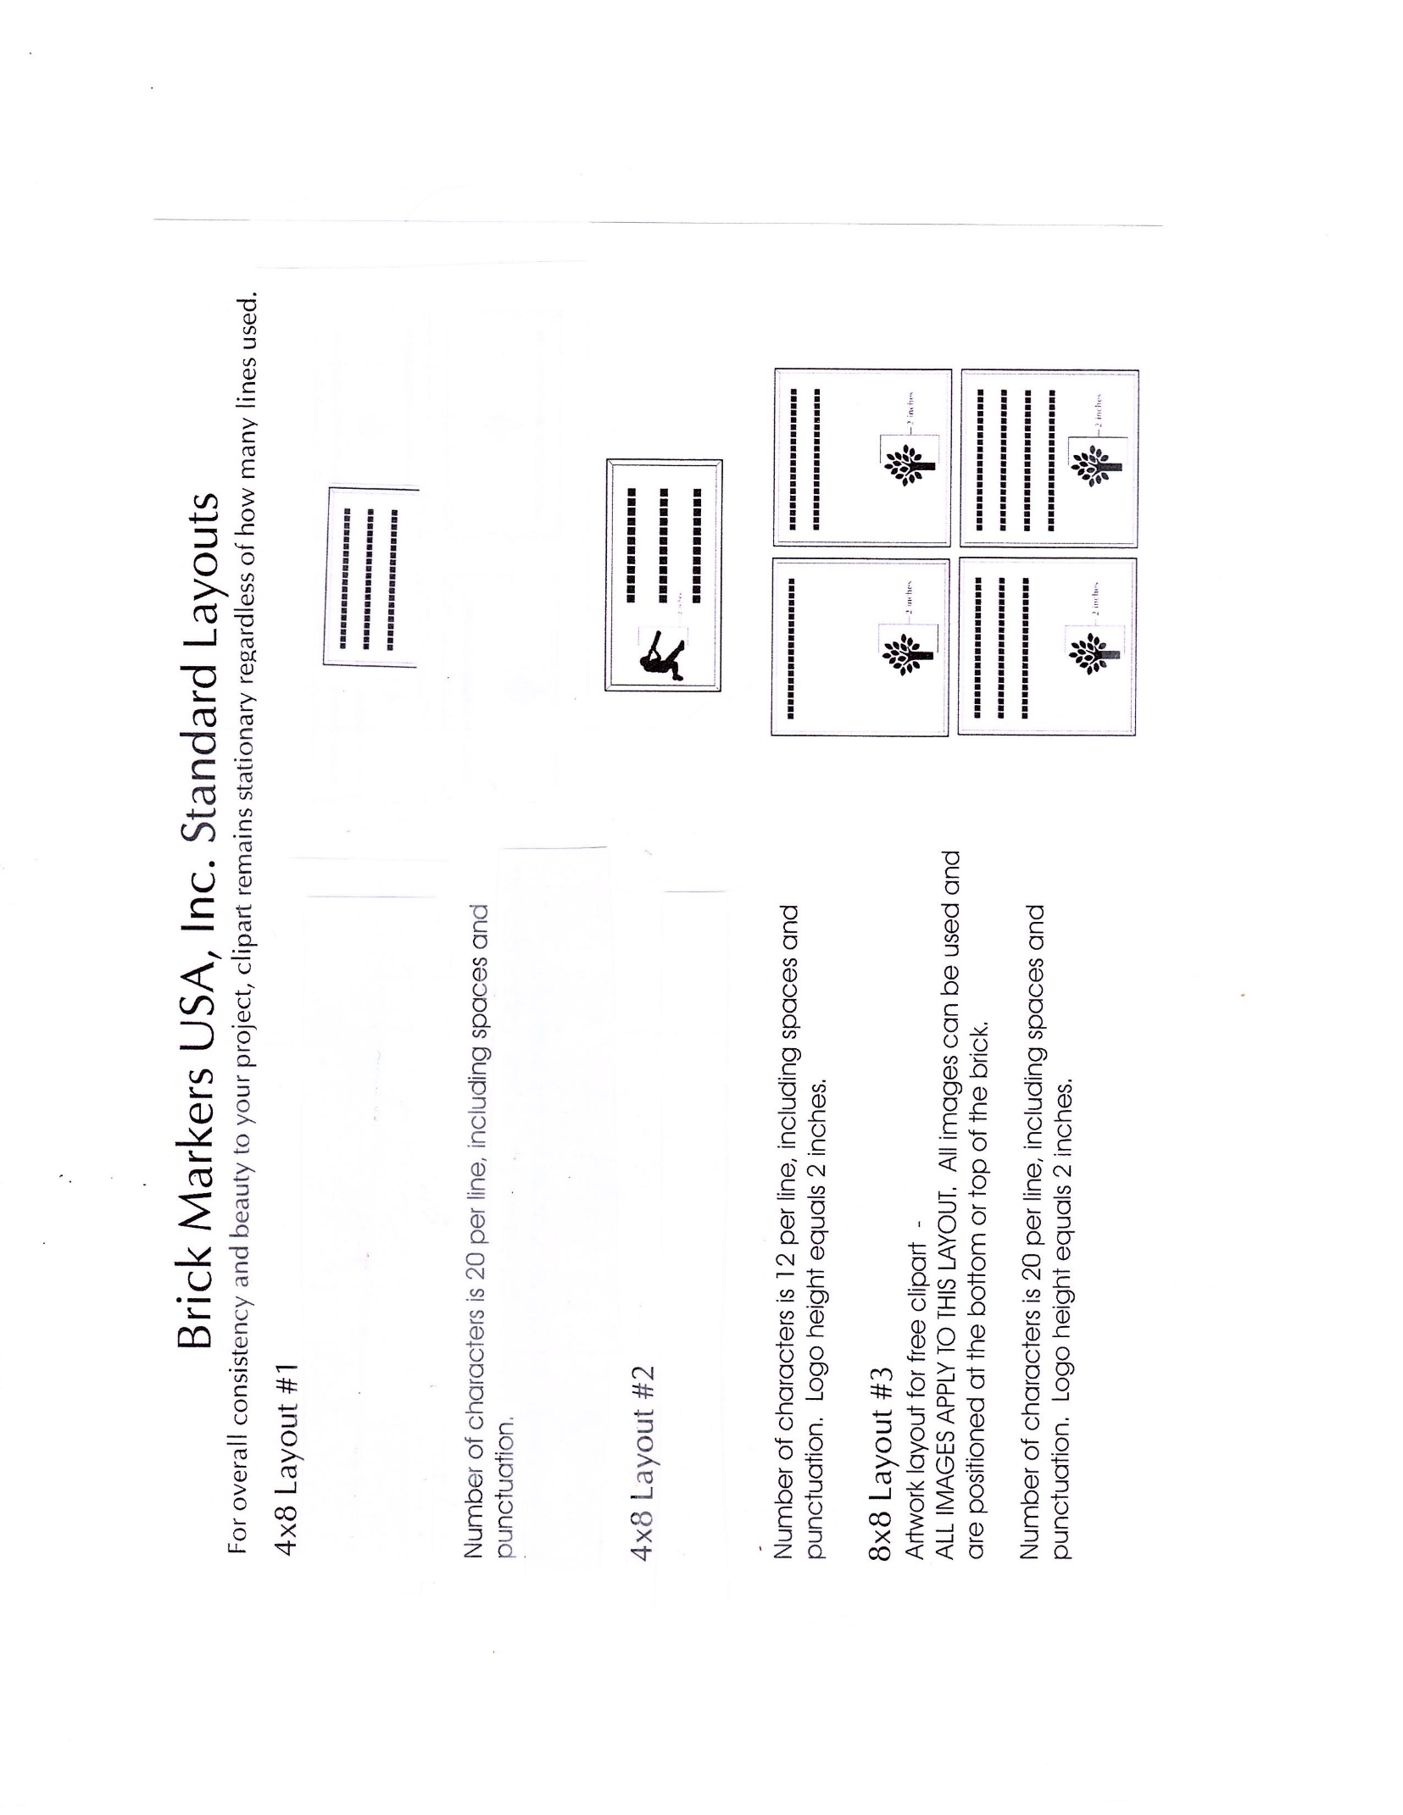

#3D

#3C

#3B

#3A